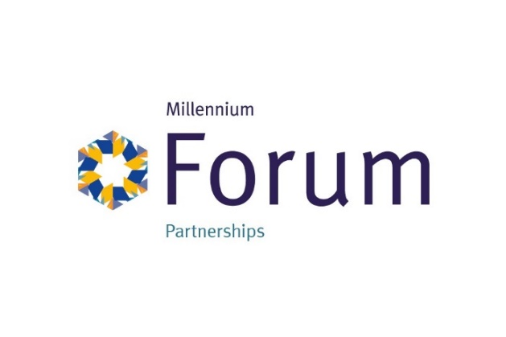

“Drama Craft, Unleash Your Inner Playwright”

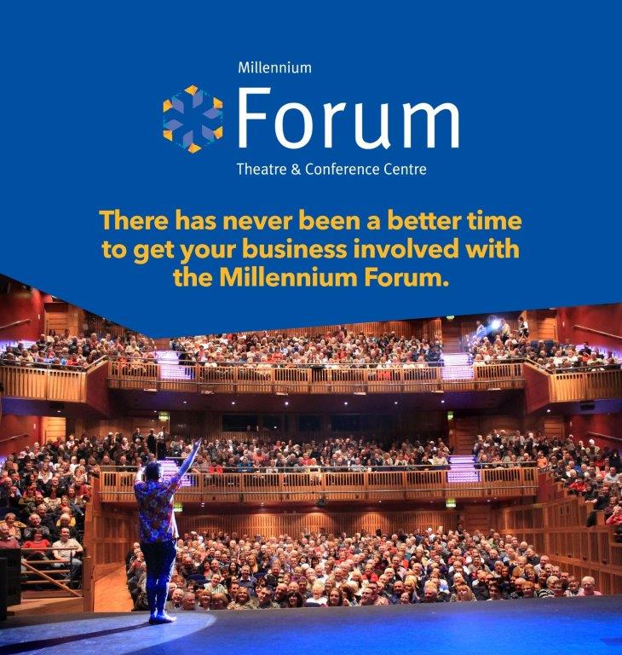

The Millennium Forum Theatre and Conference Centre is currently entertaining and educating over 320,000 people per annum who come through its doors to a variety of shows, from ballet to Broadway musicals to local productions. We can boast a proactive community and school outreach programme as well as an award winning access programme, which works to get people from all backgrounds interacting with culture and the arts.
As the leading theatre organisation in the North West, we are dedicated to promoting and sustaining the dramatic arts.
In recent years we have noticed a decline in both playwrights and drama attendance. To address this issue and cultivate a new generation of playwrights, we are thrilled to introduce our Drama Writing Workshops.
These workshops will be led by the award winning playwright, Brian Foster. Brian’s expertise and experience in the field make him the perfect mentor to nurture budding talents and inspire the next generation of playwrights.
Brian Foster will conduct a series of workshops covering various aspects of drama writing, from character development to storytelling techniques, aimed at enhancing the skills of participants.
By supporting this initiative, you will play a crucial role in revitalizing the dramatic arts scene in Northern Ireland, paving a way for fresh, innovative voices in theatre. We would welcome your input and insight with this project.
However, to make this vision a reality, we require financial support to cover the costs associated with these workshops.
If you believe that your organisation shares our commitment to the arts and the importance of fostering emerging talent, please, get involved!
By partnering with us, you will not only be investing in the future of theatre but also positioning your company as a patron of the arts and a supporter of cultural enrichment in the local community.
The Millennium Forum is a not for profit registered charity, so your monetary support is reinvested into the work that we do and it makes it possible for us to develop important artistic and educational work for our communities.
Benefits included in this package
Branding
- 12 months digital adverts on 5 free standing screens.
- Acknowledgement via your logo, in our sponsorship section of our seasonal programme of events, 60,000 copies per annum.
- Discounted advertising on printed packages.
- A photograph will be taken and pushed out on our digital channels and may also be used on our Website in the support section. 320,000 visitors.
- Digital advertising on our newsletter E-zines, 3 times a year.
- Inclusion in our Access Newsletter, targeting over 600 members.
- Web site branding/ hyperlink
- Invite to Millennium Forum events

Entertainment
- Complimentary tickets for selected Millennium Forum shows and events
- The Opportunity to apply for match funding from Arts & Business in order to carry out an art or cultural project in association with your Company, terms and conditions apply.

The cost of this package is £3,500 plus VAT per annum.

