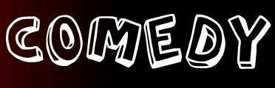
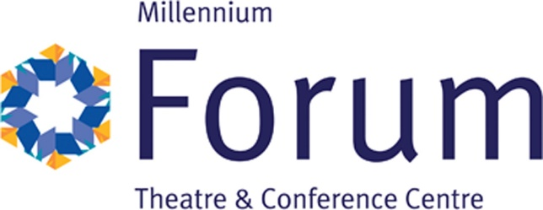
Opportunity for a 2 year Principal Partner of Comedy in the Millennium Forum.
Comedy is great medium to get attention for your business.
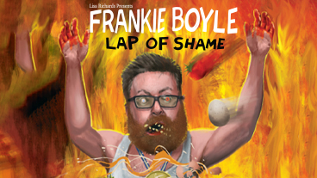
Humour humanises brands and helps to emotionally connect with customers. This creates trust and engagement.
Comedy can help to make your brand unique and differentiate it from other companies.
The Millennium Forum is inviting you to put your Funny Business on our stage.
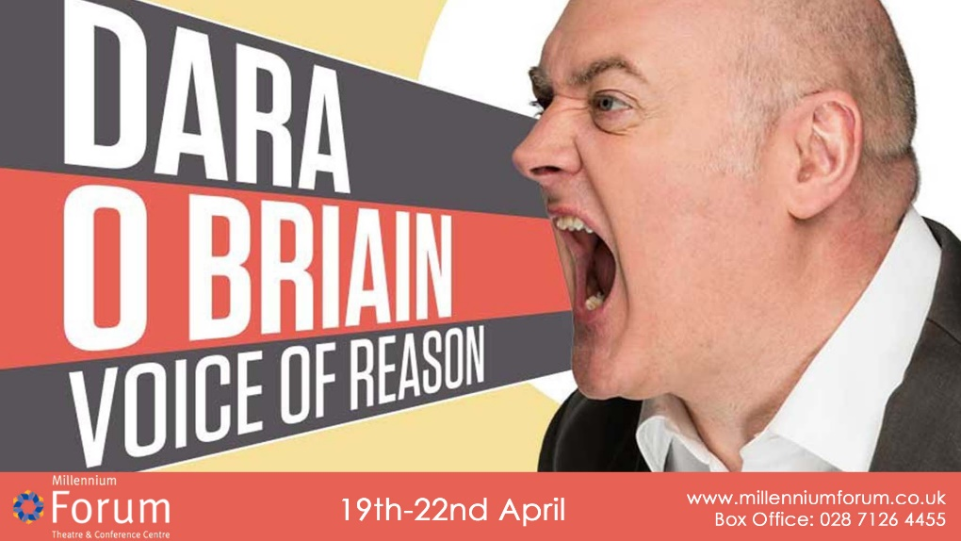

The Millennium Forum is inviting companies to come and tickle our Funny bone by launching an exciting new sponsorship venture. As part of our continued development of the venue we would like to offer a company the opportunity to become the official comedy sponsor of the Millennium Forum.
The Millennium Forum Theatre and Conference Centre is the premier theatre in the North West of Ireland. Centred in the heart of Derry City the Millennium Forum welcomes 340,000 plus visitors through its doors every year and offers a vast array of shows including comedy, musicals, drama and Broadway shows.
One of the highlights in our theatre would be our stand-up comedy nights. We have several sold out comedy nights each season.
This is one of the main attractions and a consistent high ticket seller. There is a very long list of household names of comedians that regularly perform in the Forum as they tour the country. The Forum has hosted names such as Tommy Tiernan, Jimmy Carr, Dara Ó Briain, Kevin Mc Aleer and Ardal O’Hanlon. The venue also plays host to high profile comedy plays such as Mrs Brown’s Boys. Each season the Millennium Forum strives to bring top named comedians to perform in the venue resulting in the Forum typically having on average three or four household names performing each season.
The comedy partnering company will have the opportunity to show its support for local talent and uncover the comedy stars of the future.
Becoming the Comedy sponsor of the Millennium Forum presents a number of branding opportunities for your company to take advantage of.
Your brand will be front and centre at every stand-up comedy night.
Your brand will be on our digital screens for the duration of the contract.
Your brand will be on our website with hyperlink, over 320,000 unique visitors each year. You will also have advertising opportunities on our e newsletters, we send over 60,000 each month. Your brand will also be on the sponsor section of our seasonal programme, 60,000 printed per annum.
We can also assist you with corporate entertaining and staff retention through tickets to world class shows.
We would be delighted to have a discussion with your company to see how we can work together to promote both brands through fun filled nights at the Millennium Forum.

Cost of Partnership is £8,000 per annum plus VAT

