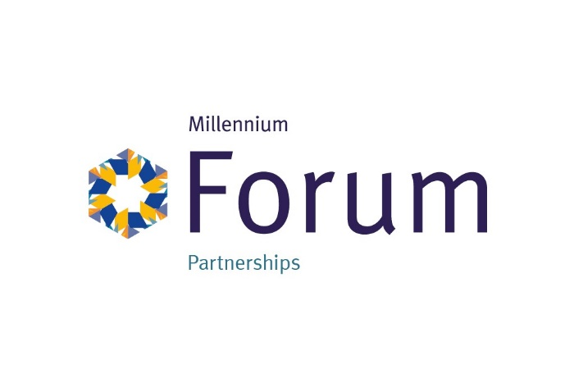

Opportunity to be the Principal Partner of Our New Project
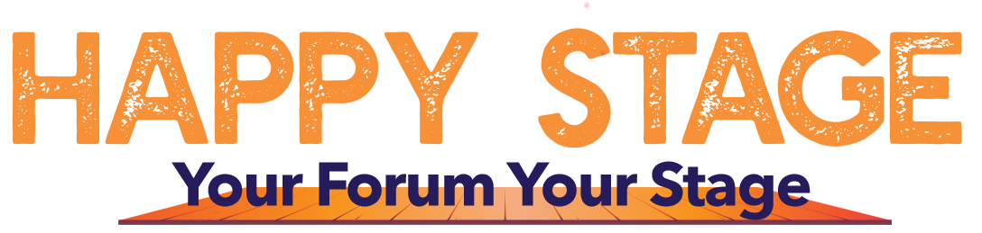

The Millennium Forum strives to serve all of the community. We offer a diverse range of high-integrity artistic and cultural events from international touring productions and locally produced ones. Our main objective is to be accessible and welcoming to all, providing a memorable experience regardless of personal needs and abilities.
We have devised a new innovative project entitled Happy Stage, Your Forum your Stage backed by Arts Council NI and the Ulster garden Villages. This innovative project is sure to attract a lot of positive PR attention.
This will be a youth led drama project by our Youth Forum, which will work with drama and health professionals and connect with the community to explore young people’s mental health through the tools of drama, dance, song and peer to peer learning. The project is aimed at 12 to 18 year olds. Considering 1 in 5 children experience mental health problems before they leave primary school this seems to be the appropriate age group to focus on.
We will aim to improve the emotional, physical and social wellbeing of participants through Drama, Dance, Song and Peer to Peer learning. We will deliver high quality free drama opportunities, delivered from professionals. This project will run over a period of 36 weeks from launch to completion.
Cost of this sponsorship is £5,000 plus VAT for 12 months.

Branding Benefits
- 12 months Digital Adverts on our 5 free standing screens, targeting every theatre goer in the Millennium Forum, including Panto and all top shows.
- You will have space for a banner stand to be placed in the Happy Stage showcases (min of 4 taking place out in the community) and at 50 rehearsals in house in the Forum studio.
- Acknowledgement via your logo, in our sponsorship section of our seasonal programme of events, 60,000 copies per annum.
- Acknowledgement in videos with the opportunity for a representative to be recorded showing your support, this will be pushed out on all our Social media platforms.
- Numerous photos opportunities will be presented including the launch, roll out and community performances. These photos combined with the good news stories showing your support will be taken and pushed out on our digital channels.
- Your logo on our website with hyperlink.
- Your support will be highlighted in all correspondence to participants, including emails.
- Your logo will accompany all call outs, and will be integrated into all promotional material. Including flyers, digital ads, banners with tags to accompany all social media.
- Inclusion in our Educational Newsletter to educational authorities, teacher forums, youth databases and the Millennium Forum database of 70k subscribers, e newsletters to our business database announcing the partnership.
Entertainment
- Tickets to selected Millennium Forum shows
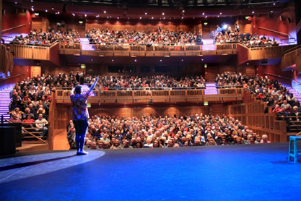
- Complimentary entrance to our Walled City Brewery Speakeasy VIP lounge.

